Experiment No.: 1
1.Title: Demonstration of Inline, Internal, and External JavaScript
2. Software/Tools Required: VSC,HTML,CSS
3. Theory:
Inline CSS: Inline CSS is written directly inside an HTML element using the style attribute. It is used to apply styling to a single element only. This method has the highest priority among CSS types. It is useful for quick changes but makes the code less reusable.
Internal CSS: Internal CSS is written inside the <style> tag within the <head> section of an HTML document. It is used to style multiple elements on the same webpage. This method keeps styles separate from the HTML content. It is suitable for single-page websites or small projects.
External CSS: External CSS is written in a separate .css file and linked to the HTML document using the <link> tag. It allows the same stylesheet to be used across multiple webpages. This method improves code organization and maintainability. It is the most commonly used approach in professional web development.
CODE:
<html>
<head>
<title>My Profile</title>
<style>
body{
font-family: Arial;
background:#f2f2f2;
}

.card{
width:350px;
margin:80px auto;
padding:20px;
background:white;
border-radius:10px;
text-align:center;
box-shadow:0 0 10px gray;
}

button{
padding:10px 15px;
margin:8px;
border:none;
border-radius:5px;
background:blue;
color:white;
cursor:pointer;
}

button:hover{
background:green;
}
</style>
</head>
<body>

<div class="card">
<h2>Welcome!</h2>

<p><b>Name:</b> Ayushi Ray</p>
<p><b>PRN No:</b> 24070521145</p>
<p><b>Course:</b> B.Tech CSE</p>
<p><b>College:</b> SIT Nagpur</p>

<button onclick = "console.log('Welcome Ayushi Ray'); alert('Welcome, Ayushi Ray Inline executed')"> Inline CSS </button>
<button>Internal CSS</button>
<button onclick = "console.log('Welcome Ayushi Ray'); alert('Welcome, Ayushi Ray External executed')"> External CSS</button>
</div>

<script>
console.log("Welcome to my webpage!"); alert()
</script>

</body>
</html>

4. Output:
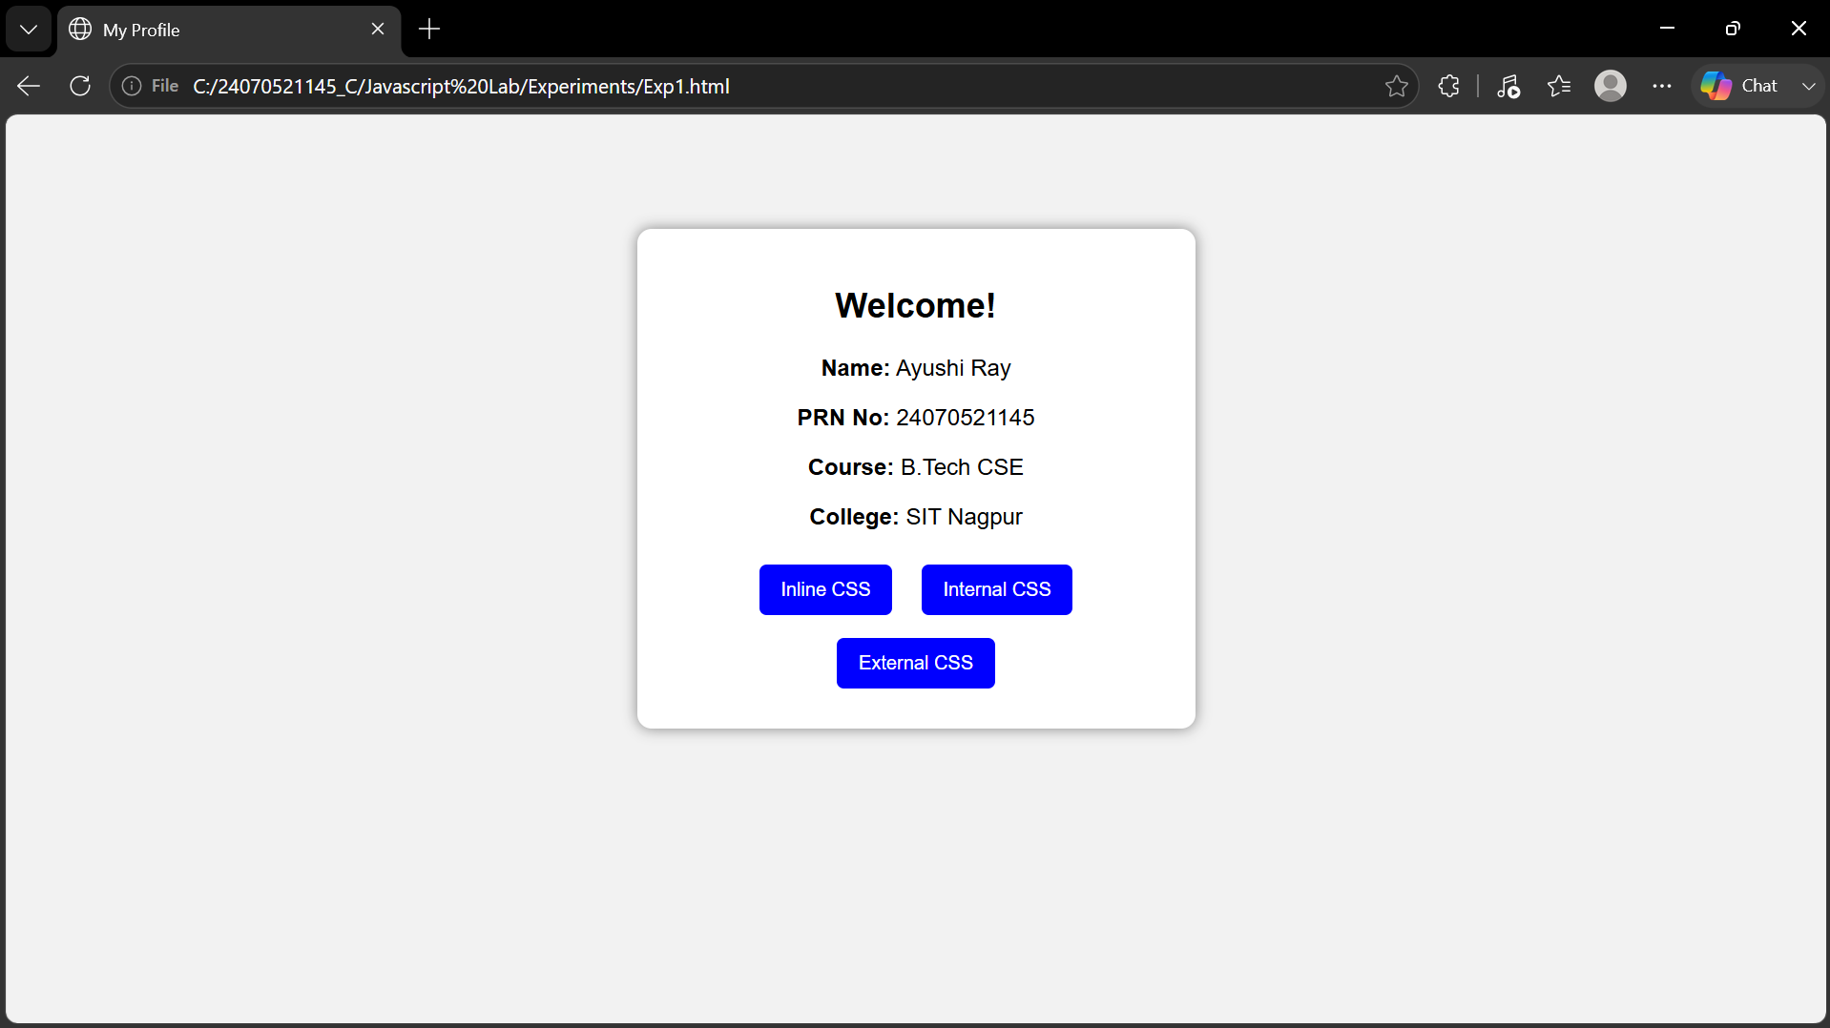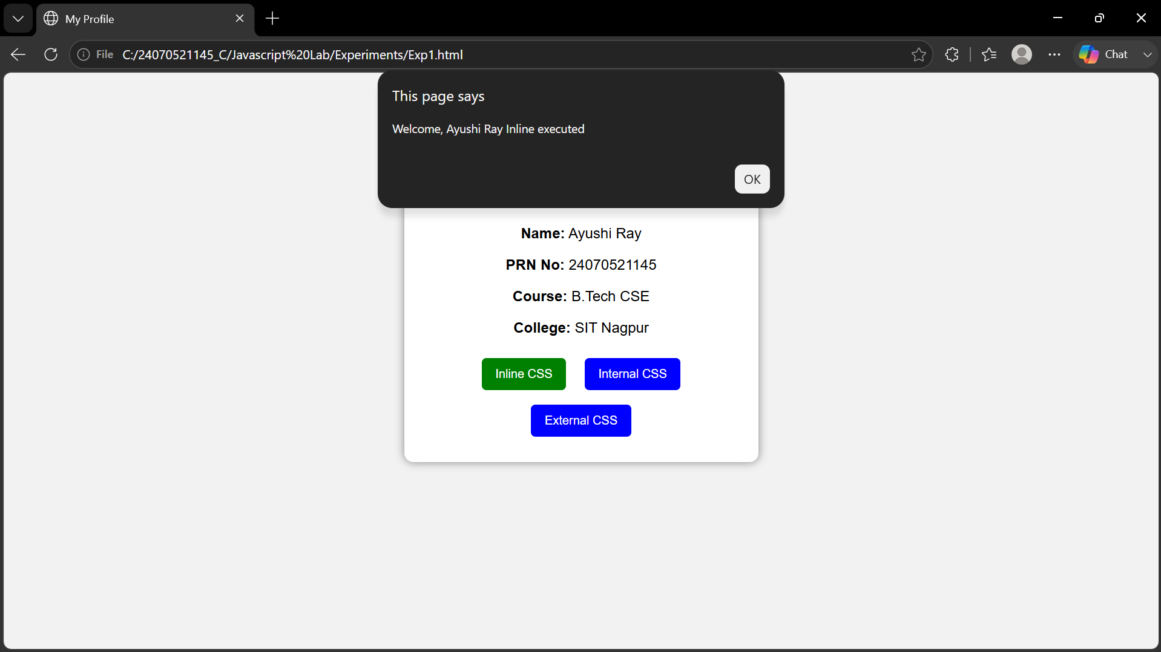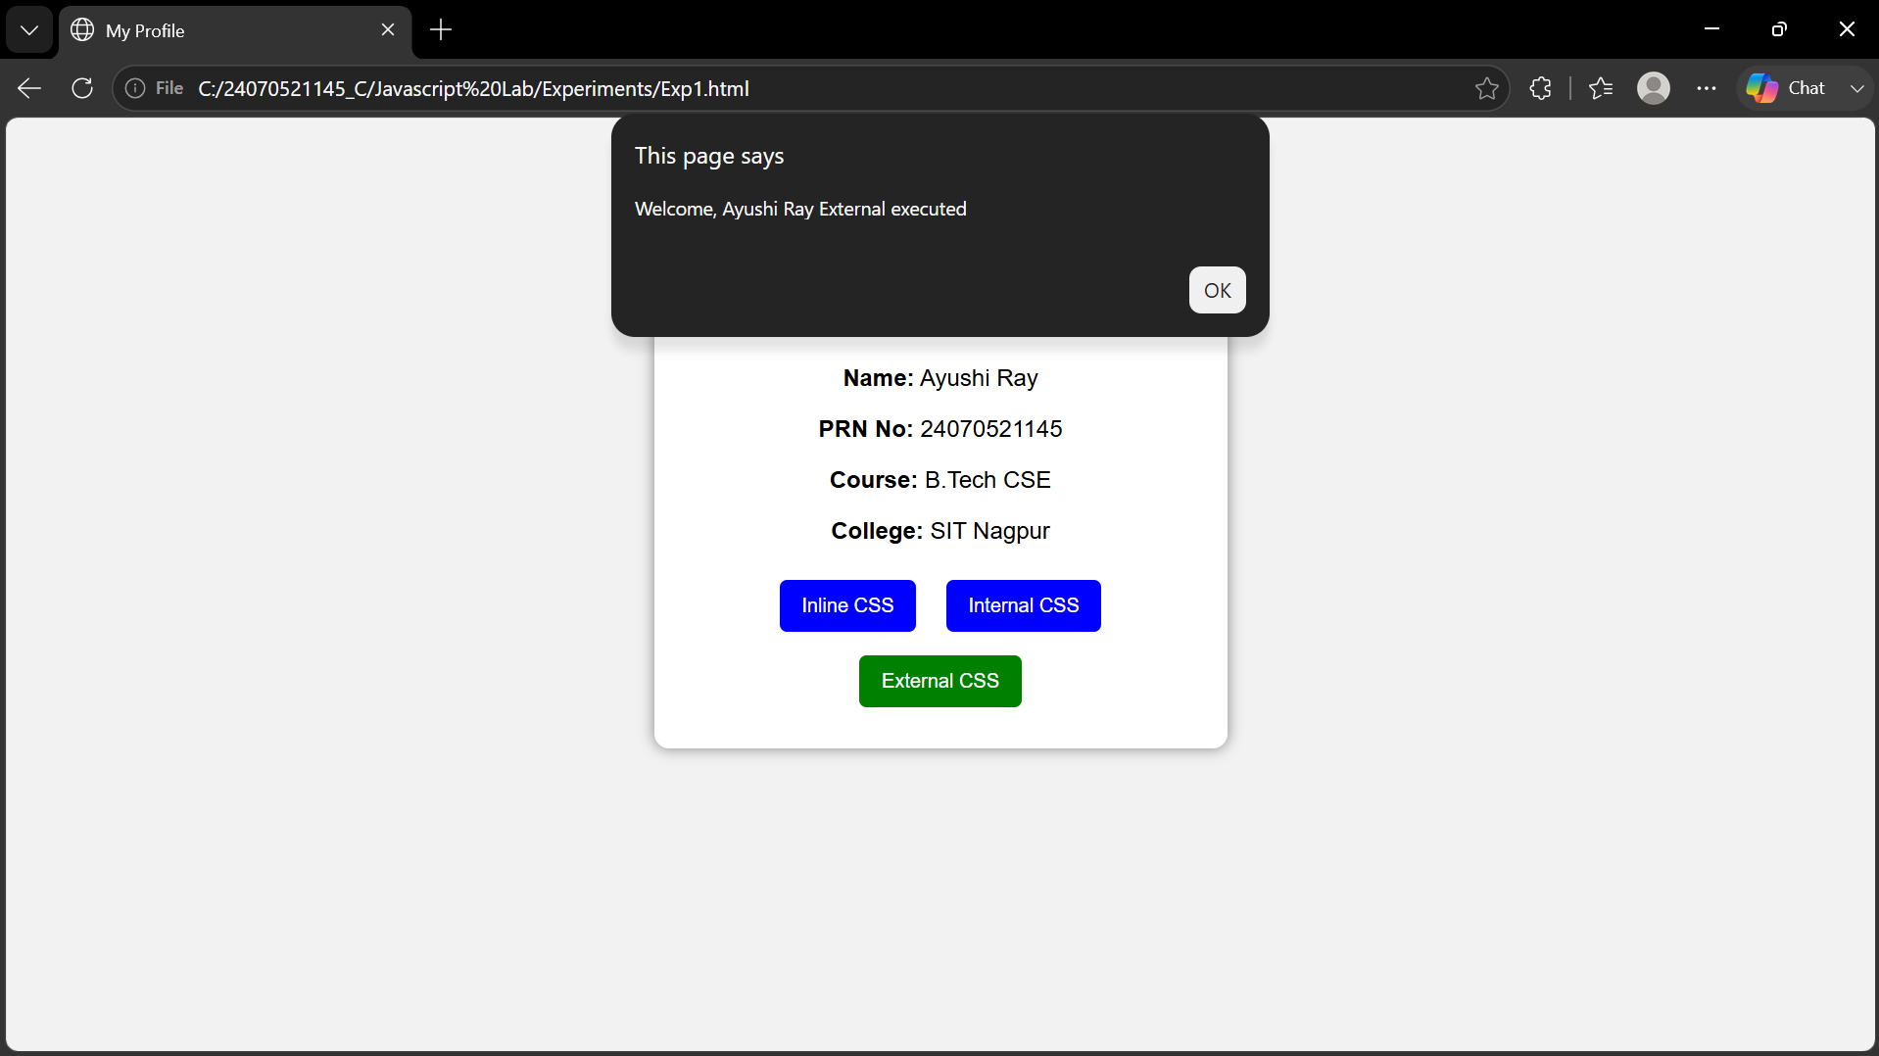
5. Result/Conclusion:
The webpage was successfully created using inline, internal, and external CSS. Different styling methods were implemented and compared, and the webpage displayed the required content with the desired formatting.

